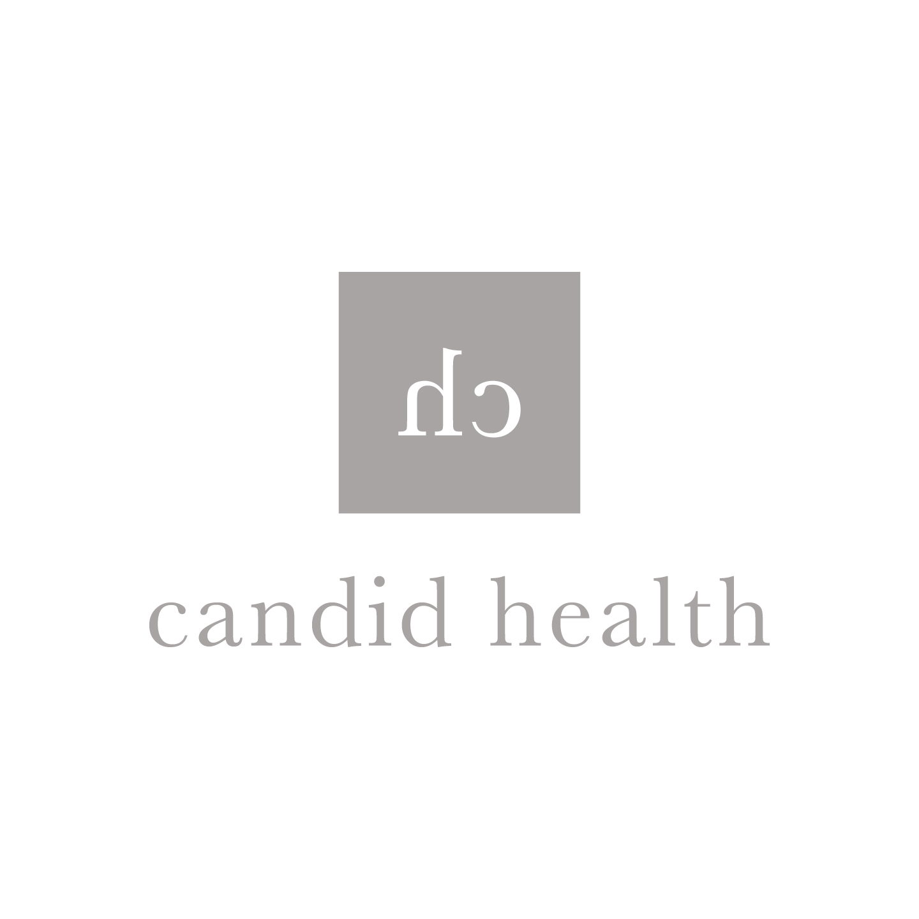

AFFILIATE DISCLOSURE

Some of the links on my blog are affiliate links. This means that if you decide to purchase a product from the link, I will receive a small commission, at no additional cost to you.
A blog post or page will always state when there are affiliate links present. Also, I will always state when product(s) were sent to or paid me for a review, otherwise, you can assume they were purchased with my money.
I am a participant in the Amazon Services LLC Associates Program, an affiliate advertising program designed to provide a means for me to earn fees by linking to Amazon.com and affiliated sites.
The affiliate links help support this Candid Health. Please know that I only partner with brands that I enjoy, believe in and sincerely recommend. Thank you so much.
If you have any questions about this, please do not hesitate to contact me.

